

**SOFE4790 Distributed Systems (Fall 2021 - Dr. H. Singh)**

**Individual Programming Assignment #1**

**Name**: Liangji Chen

**Banner ID#**: 100528902

**Overview**

The idea of my assignment is creating a reservation logging system for businesses. The staff can log the reservation information from any computers within their store, and information will be stored to a centralized file on a single server.

Also, staffs are able to retrieve and review the entire reservation information from any computer.

This application can improve the efficiency of the business since it allows staff to work on any computer located within the store seamlessly.

Services

* Any client can update the log file on the server
* Any client can review the entire log file from the server (contains entries from all clients)

Features

* When a client machine is online, the server side will have visual confirmation. Also, server will confirm whenever a client is offline.
* When a client machine made an entry, the system will log the current time
* When a client is online, it can know the status of log file (file existing, or a new file is created)
* The text entry to the log file is padded with space for ease of reading
* Each log entry is marked with client number and system time.

**Screenshots with explanations**

The server is newly started with a single client (Machine 1). User enters the reservation information on the client side. Once entered, the information is stored in the guest_log.txt file and confirmed on the server side. Server side says “File already exists” because the guest_log.txt is already exist.

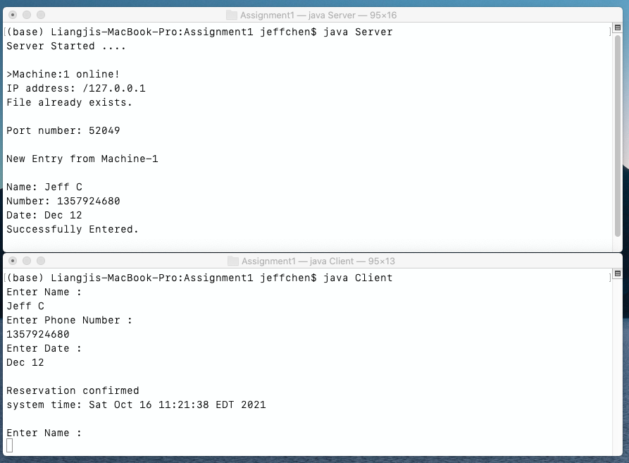

The 3rd line is just newly entered:

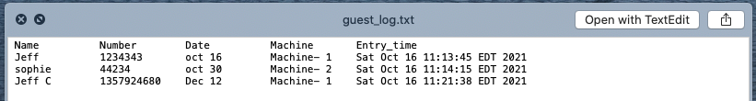

Now a new client is online (Machine 2), it is recognized by the server. A new piece information is entered from it.

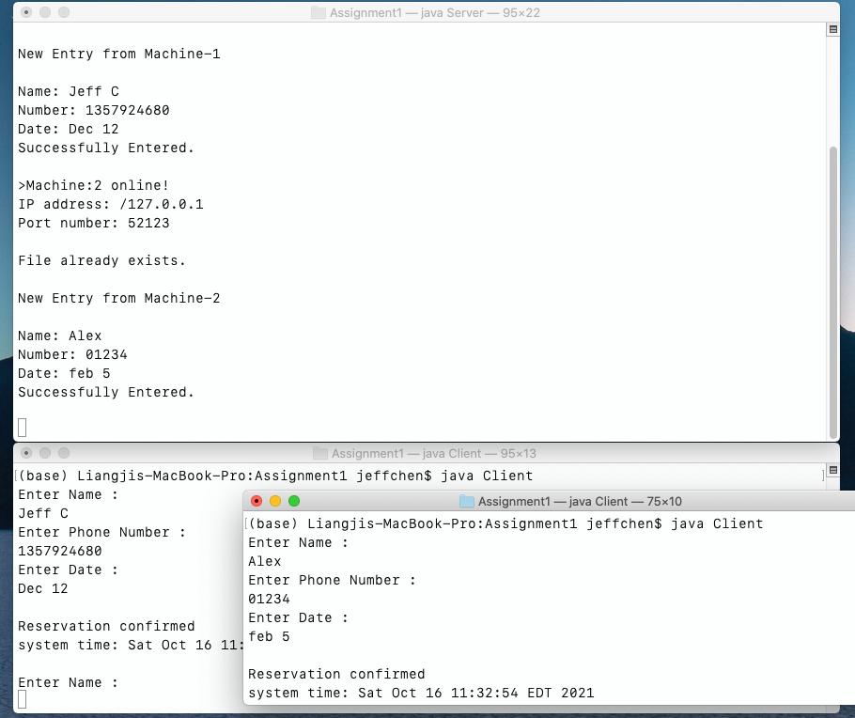

We can confirm guest Alex is entered in the log

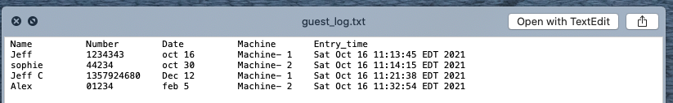

Client Machine 3 is online now. Not only it can enter the reservation info as other clients, it can also read the log file directly from the server. User has to use the keyword “read” in the name field, and leave other two fields empty.

All the information within guest_log.txt is displayed on the client side. On the server side, it knows which client is accessing the guest information.

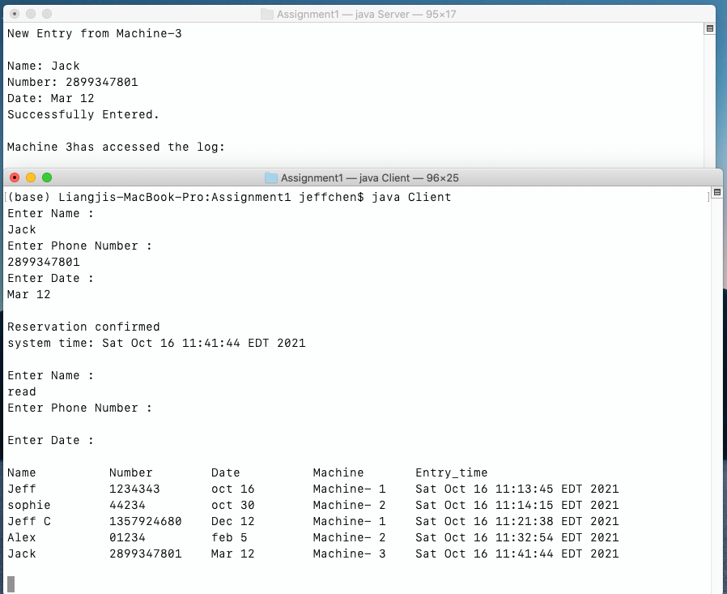

Server display information when client is offline (using ctrl-C to end client)

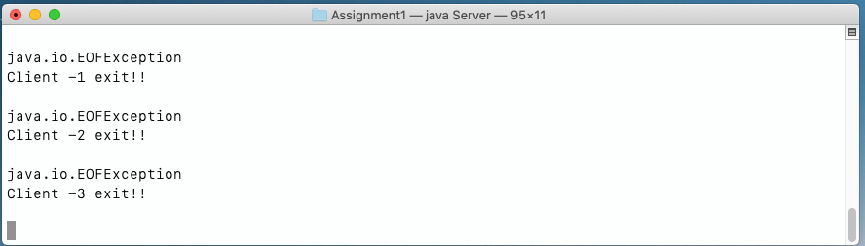

**Conclusion and Challenges**

One imperfection of this project is that user has to enter the keyword “read” in the name field, and leave others blank to access the log on client side. This could be confusing and need some learning curve for the users.

Also, the client machine number is assigned by server based on their online sequence. It is better to assign them a unique identifier based on their IP address or hardware information.

A txt file is used to store and retrieve information. Has to use the “true” keyword to make the file append-able when writing to the file.

GitHub submission link

https://github.com/UOITEngineering2/assignment1fall2020-jeffclj67